**PIZZA SALES**

**KPI’s**

**1.Total revenue of Pizzas.**

Select round(sum(total_price),2) as total_revenue from pizza_Sales;

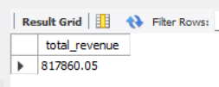

**2. Total Pizzas Sold**

select sum(quantity) as total_quantity_sold from pizza_sales;

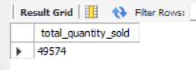

**3. Total Orders**

select count(distinct(order_id)) as total_orders from pizza_sales;

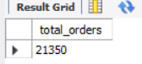

**4. Average Order value**

select round(sum(total_price)/count(distinct(order_id)),2) as avg_order_value from pizza_sales;

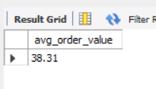

**5. Average Pizzas Per Order**

select sum(quantity)/count(distinct(order_id)) as avg_pizzas_order from pizza_sales;

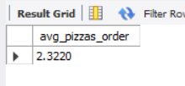

**6. Daily Trend for Total Orders**

SELECT

DAYNAME(STR_TO_DATE(order_date, '%d-%m-%Y')) AS Day_Name,

COUNT(distinct(order_id)) AS Total_Orders

FROM pizza_sales

GROUP BY DAYNAME(STR_TO_DATE(order_date, '%d-%m-%Y'))

Order by Day_Name;

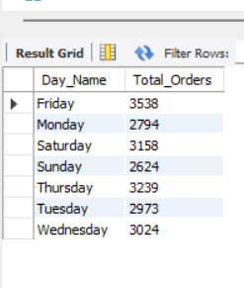

**7. Busiest Hour of the Day (Most Orders)**

select hour(order_time) as order_hour, count(distinct(order_id)) as total_orders

from pizza_sales

group by hour(order_time)

order by total_orders desc

limit 1;

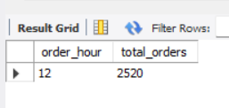

**8. Hourly Trend for Orders**

select hour(order_time) as order_hour, count(distinct(order_id)) as total_orders

from pizza_sales

group by hour(order_time)

order by order_hour;

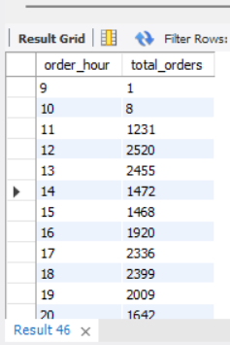

**ANALYSIS**

**9. % of Sales by Pizza Category**

select pizza_category,round(sum(total_price),2) as total_revenue,

round(sum(total_price)*100/(select sum(total_price) from pizza_sales),2) as pct

from pizza_sales

group by pizza_category;

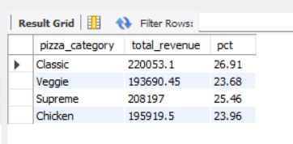

**10. % of Sales by Pizza Size**

select pizza_size,round(sum(total_price),2) as total_price,

round(sum(total_price)*100/(select sum(total_price) from pizza_sales),2) as pct

from pizza_sales

group by pizza_size;

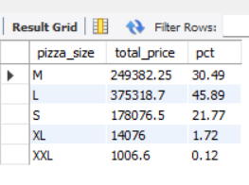

**11. Total Pizzas Sold by Pizza Category**

select pizza_category, sum(quantity) as total_sold_pizzas

from pizza_sales

group by pizza_category;

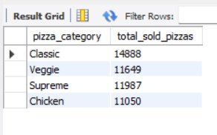

**12. Top 5 Best Sellers by Total Pizzas Sold Revenue**

select pizza_name,round(sum(total_price),2) as total_revenue

from pizza_sales

group by pizza_name

order by total_revenue desc

limit 5;

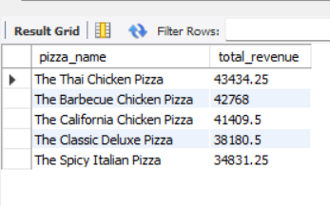

**13.  Bottom 5 Best Sellers by Total Pizzas Sold Quantity**

select pizza_name,sum(quantity) as total_quantity

from pizza_sales

group by pizza_name

order by total_quantity

limit 5;

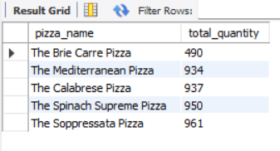

**14. Total Orders per Day**

select order_date, count(distinct(order_id)) as total_orders from pizza_sales

group by order_date;



